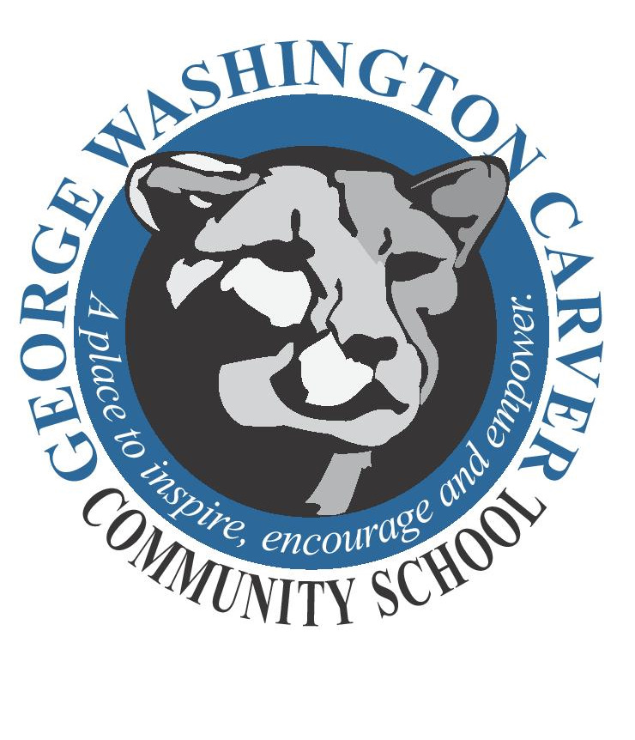 | George Washington Carver Community School  705 E. University Ave., Des Moines, IA 50316/515.242.8418/515.323.8613 (fax)  Jill Burnett Requist, Principal Stephanie Hudson, Associate Principal  George Washington Carver’s Mission Statement  At Carver, students are challenged to learn with a growth mindset, encouraged to do their  best, and motivated to succeed in a safe, caring environment.

Quick Glance Reference 2023-2024
SCHOOL HOURS (PK – 5): 7:45 A.M. – 2:40 P.M. Students are to be dropped off at the front entrance of the school. The west doors will be used for entrance/exit by bus students only. The building opens at 7:30 A.M. Students may enter the building, pick up their breakfast and report to their classrooms starting at 7:30 A.M.
- For safety reasons, parents and childcare providers are asked to wait outside the building at the end of the school day. At dismissal (2:40 P.M.), students will exit the building through the front doors with their classes. Please use the sidewalk (staying off the grass) when leaving the school building and obey all traffic signs. Park only in designated spots and do not leave your car unattended in the traffic lines (center and left lanes).
- Staying after school: No student will be kept beyond 2:50 without prior communication with parents.

For the safety of all, parents who pick up students anytime during the school day must call the office from the front door, enter, and go immediately to the office. Students will be called to meet their parent(s) at the office. Students will be released only to their parents or legal guardians and to those persons listed as emergency contacts in Infinite Campus. Picture IDs are required for student pick-up.

**VISITORS: A picture ID is required. Office staff will check you in notify the person you are visiting, and escort you to your location.*
*The DMPS Volunteer Application can be found on the ‘Parents’ page - see link options listed under the ‘district participation’ section on the left side of the ‘Parents’ page.

BIRTHDAY/SPECIAL OCCASION TREATS: Birthday/special occasion ‘treats’ brought to school during the day will be dropped off in the office and a member of the office staff will take these items to the appropriate classroom. Non-food items (pencils, bookmarks, etc.) or pre-packaged healthy snacks are preferred – please no balloon or flower bouquets!

VOLUNTEERS: If you would like to volunteer at Carver*, please complete the volunteer application on the district website (use the ‘quick links’ tab for ‘parents’ on the web page, select the ‘volunteer’ link, then select the link to the volunteer application). The district office will notify (email) applicants and schools when volunteer applications have been approved.

MIDDLE/HIGH SCHOOL STUDENTS: Secondary students are not to be on Carver’s property before 2:55 unless authorized to pick up younger siblings from school.

ILLNESS: Nurse Danielle will continue to provide updates about COVID 19 and other health issues that may arise. To protect the health of everyone at Carver, please keep your child home if he/she has: an oral temperature of 100 degrees or greater, vomiting, diarrhea, or undiagnosed rashes and contact Nurse Danielle to explain her/his symptoms. Also, please report communicable diseases such as head lice, chickenpox, pink eye and strep throat to the office immediately. Please call the office (515-242-8418) if your child will be absent or tardy; If you call before the office is open you may leave a voice message. You may also email Beth with attendance information: elizabeth.pirillo@dmschools.org

BICYCLES: 4th and 5th graders may ride their bikes to school with parental permission. A bicycle registration form must be completed, and bike locks are required (the bike rack IS NOT supervised.) Bike helmets are strongly recommended.

MEDICATION AT SCHOOL: Any medication that must be taken at school must be sent in the original prescription bottle and left with the nurse. Please see the nurse with any questions regarding inhalers. The nurse must have a signed parental consent form before medication is administered at school. Over the counter drugs (non-prescription) require a doctor’s order, with the exception of cough drops and lip balm.* (*School board policy)

LOST ITEMS: Please take the time to mark personal items such as lunch boxes and coats. Lost and Found items are located outside the B & G Club door. School district insurance DOES NOT cover personal property, and students are urged NOT to bring items of value to school. Scooters, skateboards, and personal electronics are not permitted at school. Cell phones are only permitted with parent permission and must be turned off and kept in a pocket/backpack/bag during the school day. Again, Carver is not liable for the theft or damage of cell phones brought to school.

BEHAVIOR: Please work with us to encourage positive behavior. Carver Cougars are respectful, responsible and safe!

Thank you for choosing George Washington Carver for your child. We are looking forward to a great year! Please call the office any time you have a question or concern (515) 242-8418.

